Introducing the Integral as Anti-Derivative

Recall that the position function of an object gives its location as a function of time. If $x\left(t\right)=3t^{2}+t$ feet, for time t in seconds, then the derivative of x(t) with respect to time (or x’(t) or $\frac{dx}{dt}$ ) will be in feet/sec, which is the velocity, v(t). Differentiating again with respect to time will produce a second derivative of x(t), or x”(t) or $\frac{d^{2}x}{dt^{2}}$ which is measured in feet/sec², which is a measure of velocity. So:

x(t) = position
x’(t) = v(t) = velocity
x”(t) = v’(t) = a(t) acceleration

Suppose the velocity of an object, in feet per second, is modeled by the function $v\left(t\right)=\sin\left(\frac{t}{3}\right)-1$ for time $t≥0$ What is the position function x(t)?

To find this, we need to use a concept called anti-differentiation. We therefore need to find the anti-derivative, or the indefinite integral. The symbol for this is the integral sign . The integral sign cannot function on its own, as it needs a variable of integration—just as a derivative must be taken with respect to a variable. That is, if y = x², then $\frac{dy}{dx}=2x$ but $\frac{dy}{dt}=2x*\frac{dx}{dt}$ .

A quick tour of indefinite integrals (interchangeable with anti-derivative)

$\int{f(x)}dx=F\left(x\right)+C$ , where F’(x) = f(x).

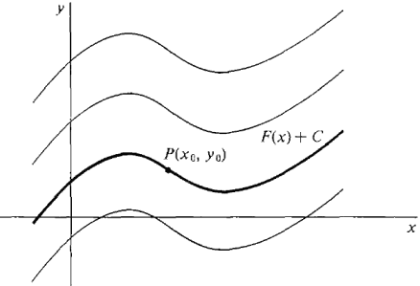
The +C is very important. It tells you that the solution to an indefinite integral is not a function but instead a family of functions, all of which vary by a vertical translation. Notice that all of these functions have the same slope:

This will be in contrast to a definite integral, whose solution is a number. You will eventually see that because a definite integral (which looks like this: $\int_{a}^{b}{f\left(x\right)dx}$) is a number, it will help us find values such as areas of complicated figures.

Let us now return to our original problem dealing with velocity. You should now notice that we are missing some information. What is it?

Translate the following into words and describe how you will use it: x(0) = 12.5 feet

Set up, but do not yet simplify, an indefinite integral which will give the position function:

Now find the anti-derivative. Don’t forget +C

Use the information about the initial position to calculate the particular position function x(t).

Example: Galileo discovered that the acceleration due to gravity of a falling object is -9.8 m/sec². Suppose an object is thrown from a 25 meter tower with initial velocity -2 m/s, meaning that’s how fast it is traveling when it leaves our hand and our timer starts. Ignoring air resistance How fast is it traveling when it hits the ground?

Homework for Weds: Complete the table below:
