Daily Journal

1. Complete the unit circle provided to you and tape it to your notebook.
2. Write as a piecewise function:

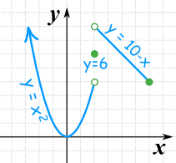

1. Write as a piecewise function and sketch 
2. Solve: tex2html_wrap_inline683

